**Lecture 1 React.js**

**React.js is a javascript liberary**

**Difference between liberary and framwork ??**

**It takes minimum effort for a liberary to just put it inside your code.**

**What is a Library?**

It’s a set of code that was previously written, that can be called upon when building your own code.

**What is a Framework?**

It’s a supporting structure where your own code defines the “meat” of the operations by filling out the structure.

## ****Tools (a hammer, a nail gun, etc) are your “Library”****

You could build the house without any tools but if you want to make your work easier, you would use ‘the set of tools’. It can be used anywhere as much as you want when needed.

## ****The foundation of the house is your “Framework”****

If there is a given foundation of the house, you must follow the regulations. Otherwise, the house cannot be built in proper way. The foundation dictates how your project will be structured.

**Emmet ??**

**When we write in code editor it will give you lots of code to us .**

you can use short expressions to generate HTML markup, CSS.

**For ex: when we write html:5 it gives us html biolerplate to us .**

**Create h1 tag using javascript dom**

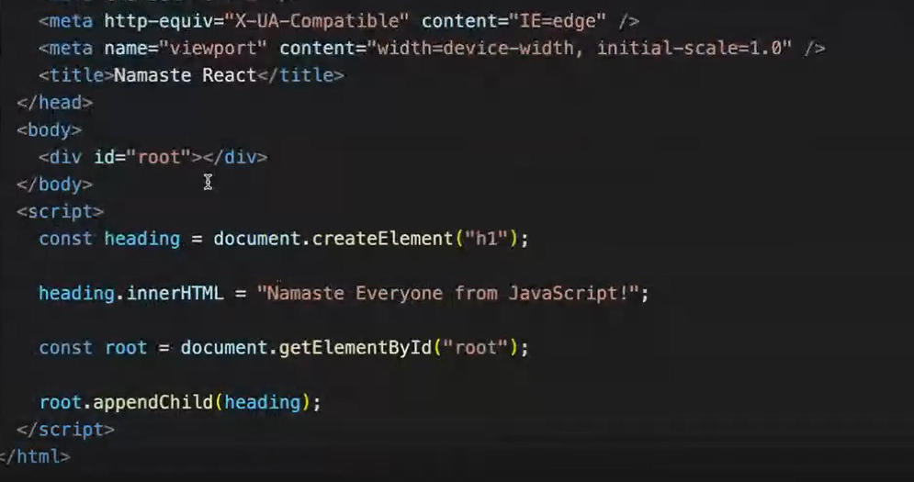

**CDN ?????**

**Content delivery network**

CDN was invented to shorten the physical distance between the website user and the website’s hosting server.

 CDN is a bunch of servers placed in different locations all over the world. To minimize the physical distance between your website and your user you can choose to deliver it through CDN which would cache a copy of your content on each of their servers.

Why is React known as React?

React is called React because it is a library that reacts to changes in data and updates the user interface accordingly.

What is crossorigin in script tag?

A cross-origin request is a request for a resource (e.g. style sheets, iframes, images, fonts, or scripts) from another domain.

What is diference between React and ReactDOM

React: React is a javascript library, designed for building better user interfaces.

React-DOM: React-DOM is a complimentary library to React which glues React to the browser DOM

In a nutshell, Whenever we use **component, classes, elements**, etc. We’re using **React** and whenever we use methods like render() or findDOMNode() we’re using **React-DOM.**

What is difference between react.development.js and react.production.js files via CDN?

React.development.js includes a lot of debugging information that can be helpful when developing an application. However, this debugging information can also increase the size of the file, which can impact performance.

React.production.js is optimized for performance and has a smaller file size. This makes it ideal for production environments where performance is critical.

What is async and defer?

Async allows your script to run as soon as it's loaded, without blocking other elements on the page. Defer means your script will only execute after the page has finished loading